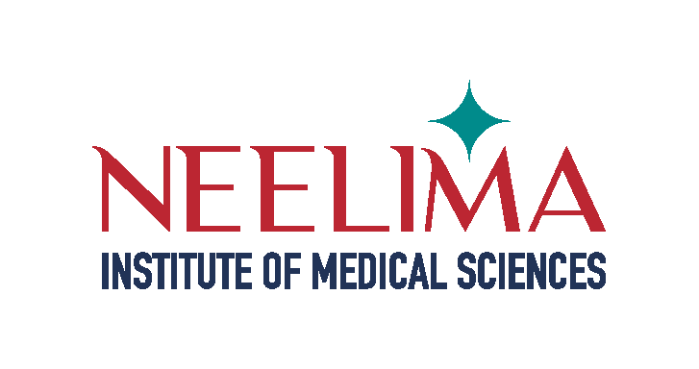


LIST OF DOCUMENTS TO BE SUBMITTED
FOR MBBS ADMISSION

- NEET Hall Ticket

- NEET Rank Card

- Provisional Allotment Order

- SSC or 10th Certificate (Original)

- Intermediate Certificate (Original)

- Bonafide Certificate/s (6 to12”) & Residence Certificate (Original)

- Transfer Certificate (Original)

- Aadhar Card Copy (Candidate and Parents Self-attested)

- Eight (08) Recent Passport Size Photographs as Affixed on the Application

- Migration Certificate/Equivalence Certificate (if applicable) (Original)

- Photo Copies of above Documents – 3 Sets

(Self-attested – 2 sets for College, 1 set for Candidate)

- University Bond (Original)

- Undertaking by Candidate & Parent (Original)

- Declaration by Candidate Bond (Original)

- Scanned Copies of Above Mentioned Original Certificates

- Latest Income Certificate (If Applicable)

- Latest Caste Certificate (If Applicable)

- EWS Certificate (If Applicable)

- NCC Certificate (If Applicable)

- PWD Certificate (If Applicable)

- CAP Certificate (If Applicable)

- Minority Certificate (If Applicable)

✓

✓

✓

✓

✓

✓

✓

✓

✓

✓

✓

✓

✓

✓

✓

✓

✓

✓

✓

✓

✓

✓

NOTE: Candidates are instructed to go through the information bulletin & Counselling Scheme of Medical Council Committee.

